Vision and Scope Document

for

Clinic Management System

**Version 1.0 approved**

**Prepared by Pham Vinh Nhan, Cao Chi Hai, Truong Binh Tan, Nguyen Thai Thinh**

**Group 1**

**September 8, 2021**

**Table of Contents**

Table of Contents ii

Revision History ii

1. Business Requirements 1

1.1. Background 1

1.2. Business Opportunity 1

1.3. Business Objectives 1

1.4. Success Metrics 1

1.5. Vision Statement 1

1.6. Business Risks 1

1.7. Business Assumptions and Dependencies 2

2. Scope and Limitations 2

2.1. Major Features 2

2.2. Scope of Initial Release 2

2.3. Scope of Subsequent Releases 2

2.4. Limitations and Exclusions 2

3. Business Context 2

3.1. Stakeholder Profiles 2

3.2. Project Priorities 3

3.3. Deployment Considerations 4

**Revision History**

| **Name** | **Date** | **Reason For Changes** | **Version** |
| --- | --- | --- | --- |
| Assignment 1 | 15/10/2021 | First init | 1.0 |
| Assignment 2 | 36/10/2021 | Add Feature Tree | 2.0 |

# Business Requirements

## 1.1 Background

Clinics have been popular with patients with some specific disease. They provide easy access to healthcare without having to go to the hospital. In most cases, patients usually wait a long time if they go to the hospital. Clinics in remote locations also play a huge role in providing healthcare services where going to hospital may not be easy. Because the number of patients is not as much as a hospital, doctors in clinics can treat patients better with more personalized treatment progress. However, patients do not remember the treatment progress, leading to ineffective treatment. There is a stable stream of patients, and it may not be easy for doctors to handle these patients, although the number of them in clinics may be small.

## Business Opportunity

A clinic management system can help doctors maintain the records of the patients on a small scale for a long duration easier. It can allow doctors and patients to be able to monitor the progress of treatment.

Some staffing problems of the clinic may occur such as no doctor, doctor randomly examines patients randomly leading to ineffective treatment, patients are treated by many other doctors. But these problems could be solved if the system can manage the appointment between patient and doctor, doctors' schedules, patients' treatment.

In addition, there are also problems related to facilities and medicines such as not managing the time of use of medicines, not controlling the facilities. To solve these problems, the system needs to manage the data of facilities and medications.

The system also runs in multi-platform such as IOS, Android, Website, Desktop. It helps patients book an appointment, check prescriptions, allow doctors to set schedules, manage the inventory, etc., on their smartphone or laptop.

The system needs to manage the clinic's business activities such as managing bills, helping patients pay easily, and making statistics on business results.

## Business Objectives

**BO-1:**

Increase the level of effectiveness in treating patients by 30% within 12 months.

**BO-2:**

Reach sales volume of the market at least 9%-12% within the next 2 year.

**BO-3:**

Return almost 40% of investments within the next 2 years.

**BO-4:**

Decrease costs for facilities management, medicine by 10% within 5 months.

**BO-5:**

Digitize 100% of the clinic’s data (doctors’ data, patients’ data, medical equipment, medicine) within 1 month.

**BO-6:**

Patients getting online appointment, which save their time, money and resource

**BO-7:**

Build the trust between doctor and patients, and patients trust the system’s suggestions about medicines and follow the treatment.

## Success Metrics

**SM-1:**

If in one week, only 10% of people use our HMS system, our metrics are achieved.

**SM-2:**

If people get help from our system that means our metrics to provide help to people is achieved.

**SM-3:**

Main objective of providing doctors to patients any time to build the faith of our customers on us.

**SM-4:**

If after one month, 10% of people use our HMS system, our metrics are achieved.

**SM-5:**

There are so many other such products in the market but our goal is to provide help to hospital staff, patients.

**SM-6:**

The app is rated above 4 stars by users in the app store.

## Vision Statement

**For** users include doctors, nurses and patients **who** need to take the online appointment, **the** clinic management system **is** internet-based and smart phone application **that** will take online appointment more convenient for both patients and medical staffs, **unlike** traditional appointment system, patient must call to the clinic to know the doctors' schedule, **our product** will show doctor’s schedule to the patients, patients can pick the time, how long the appointment is. After that, the nurse will assign the doctor to that appointment.

**For doctors**, **who** can pick their available time for nurses to assign them to patients' appointments, reate, update, and delete the patient's record which allows them to fully control their patient records. **the** clinic management system **is** internet-based and smart phone application that will let the nurse scheduled the appointment in a reasonable time, **unlike** other appointment system, the nurse needs to communication directly with the doctor to knows their available time to make appointment and the doctor must work with paper work very inconvenient, **our product** will show doctor’s schedule for the nurse so they will know doctor’s available time and will let the doctor create, update, and delete the patient's record with a few clicks.

**For patients**, who can order medicine via the online service after they get a medical prescription, **the** clinic management system **is** internet-based and a smartphone application will let the patient order medicine online. Unlike thetraditional clinic system, the patient needs to physically come to the clinic to get medicine. **our product** will let the patient order medicine and receive at home

**For nurses**, **who** can create, update, and delete the patient information, **the** clinic management system **is** internet-based and smart phone application will let the doctor create, update, and delete the patient's information online, **unlike** traditional clinic system, the nurse must work with paper work very inconvenient, **our product** will let the nurse create, update, and delete the patient's information with a few clicks

## Business Risks

RI-1: Older patients are not familiar with technology, because it loses many users. (Probability = 0.5)

RI-2: Spends a lot of money on advertising and user manual, but it is not very effective. (Probability = 0.3)

RI-3: Remote areas rarely able to connect to the internet. (Probability = 0.6)

RI-4: Small clinic not able to pay for app maintenance. (Probability = 0.3)

## Business Assumptions and Dependencies

AS-1: App will display all doctors currently available so that the patient can make an appointment.

AS-2: Doctor always able to track down treatment process of every patient through the system

AS-3: The medicine must be shown with the proper description and prices and receiving order the app show the appointment time of delivery to the patient

AS-4: Appointment information will display in detail on the system for both doctor and patient

# Scope and Limitations

## Major Features

FE-1: Register as multiple roles (patient, nurse and doctor).

FE-2: Login into MMS with MMS account and google account and authorize users as their role.

FE-3: Patients can make an appointment with a doctor and cancel appointments via the online system.

FE-4: Doctors can set their available time and create, update patient records.

FE-5: Order the medicines online and online payment through debit or credit card, delivering is also fast.

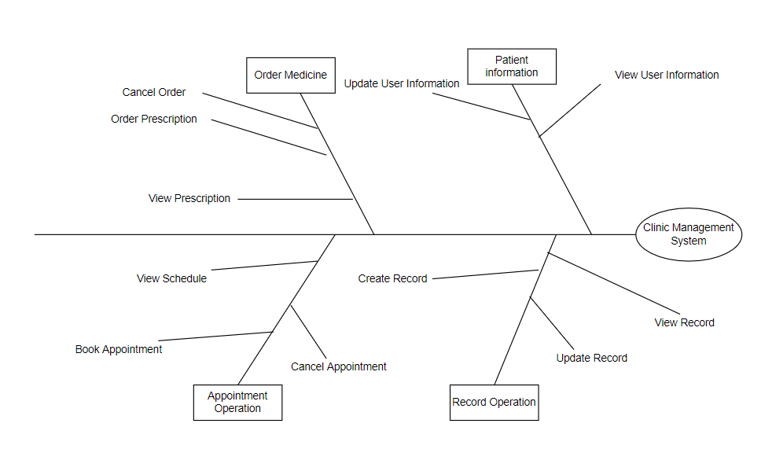

## Scope of Initial Release and Subsequent Releases

| Feature | R1 | R2 | R3 |
| --- | --- | --- | --- |
| FE-1 | Full implement |  |  |
| FE-2 | Login via MSS account |  | Full implement |
| FE-3 | Allow patient make appointment | Improve the performance of solving requests and responses. | Full implement |
| FE-4 | Doctors can set their available time and create, update patient records | Improve the performance of solving requests and responses. | Full implement |
| FE-5 | Allow doctor can set their available time | Improve the performance of solving requests and responses. | Full implement |

## 

## Limitations and Exclusions

* In case of running out of drugs or medical equipment, medical staff will send links to buy at other pharmacies affiliated with the clinic.
* The CMS shall be used only in urban areas due to the requirement of Internet connectivity.

# Business Context

## Stakeholder Profiles

| **Stakeholder** | **Major value** | **Attitude** | **Interest** | **Constraints** |
| --- | --- | --- | --- | --- |
| DOCTER | Easy managing patients and look after of more patients in less time | Strong commitment | Time saving simplicity of use | Need internet and devices for Access |
| PATIENTS | Easily taking appointment from specialists | Strong enthusiasm | Reliability and saving of time | May know the use of app and have cooperative internet access and device |
| NURSE | Easily handling and higher patient satisfaction and less hectic |  | Job preservation | Training of staff for internet usage and software usage |
| PAYROLL DEPARTMENT | No benefit | Recognize the value to the company and employees so that good relationship is maintained | Helping people at their vulnerable times | No resources  Yet committed to make software charges |
| MEDICAL STORE | Customer satisfaction and easy dealing with orders |  | Better and easily earning  Earn more money in less time | Use to know the acceptance of order and use of software. |

## Project Priorities

| **DIMENSION** | **CONSTRAINTS** | **DRIVER** | **DEGREE OF FREEDOM** |
| --- | --- | --- | --- |
| FEATURES | All features scheduled for release 1.0 must be fully operational |  |  |
| QUALITY | 95% of user acceptance tests must pass; all security tests must pass |  |  |
| SCHEDULE |  |  | Release 1 planned to be available by end of next year, release 2 by end of Q2: overrun of up to 2 weeks acceptable without sponsor review |
| COST |  |  | Budget overrun up to 15% acceptable without sponsor review. |

## Deployment Considerations

After developing and testing, the final step is to deploy the website to the internet. Apps will have to be developed for IOS and Android smartphones and tablets as part of the second release, with corresponding apps for tablets to follow for the third release. We may need to train the doctor and nurse before letting them fully control the system. We also need a short video to teach the patient how to use the new system to take the appointment. Videos no more than five minutes in length shall be developed to train users in both the Internet-based and app-based versions of CMS. The new website version will support by all modern browsers including Firefox (v28.0.0), Chrome (v29.0.0 or higher), Opera (v12.1.0 or higher), Safari (v6.1.0), Safari on iOS (v7.0.0), Android Browser (v4.4.4), Chrome for Android (v94.0.0). Moreover, The mobile version will support all devices which need 1GB or higher, and running on ISO (v7.0.0 or higher) or Android (7.0 Nougat or higher).